Image | 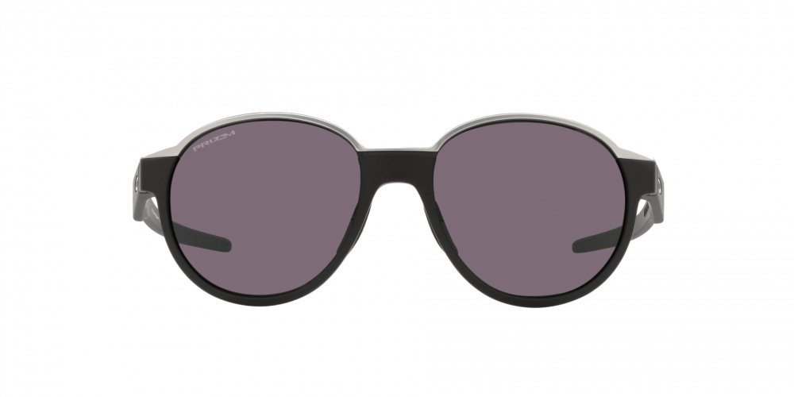
Brand | OAKLEY
Model Name | COINFLIP POLISHED BLACK
Price | RS 5999
PRODUCT DETAILS

